Assignment 1

Question A

Apply both Canny Edge Detection and Sobel Edge Detection to only the face area of the image using a suitable threshold values. (5 Marks)

Canny Edge Detection

Resulted output:

The images above are facial expressions for smile, angry, and normal.

Steps:

1. Call the previously taken picture.
2. Using face detection, detect and apply rectangle shape on the face.
3. Apply Canny onto the inside of the rectangle.
4. Repeat steps on other faces.

Sobel Detection

Resulted output:

The images above are facial expressions for smile, angry, and normal.

Steps:

1. Call the previously taken picture.
2. Using face detection, detect and apply rectangle shape on the face.
3. Apply Sobel onto the inside of the rectangle.
4. Repeat steps on other faces.

Question B

B) Perform blurring of only faces in those images. (5 Marks)

Resulted output:

Steps:

1. Call the previously taken picture.
2. Using face detection, detect shape on the face.
3. Apply blurring onto face.
4. Repeat steps on other faces.

Question C

Calculating the number of coins in an image using contours. (5 Marks)

Resulted output:

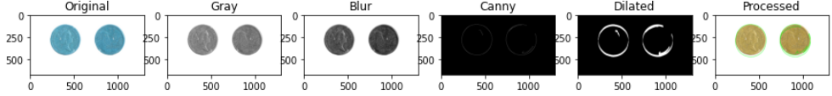

Steps:

1. Call the saved picture of coins.
2. Apply grey, blurring, Canny, dilated, and contour.
3. From contour, print the number of coins from the detected contour.